Chapter 8

Finite Element Simulation and Biomaterial Selection Using COMSOL Multiphysics

Introduction
The mechanical and thermal behaviour of a powered lower-limb prosthesis cannot be judged from geometry and intuition alone. Before the components of the Brain–Computer-Interface (BCI) controlled prosthesis were committed to manufacturing, each load-bearing part had to be shown to satisfy two requirements: first, to carry the forces generated during stance and actuation without yielding; and second, to remain within a safe temperature range, so that neither the printed polymer nor the underlying human tissue is damaged by the heat conducted from the motor, lead screw and bearing assemblies.
To address these requirements, the project used COMSOL Multiphysics, a finite-element platform that solves the partial differential equations of structural mechanics and heat transfer on the same imported computer-aided-design (CAD) geometry. This chapter describes the software, the governing physics, the way candidate biomaterials were classified and the polymer selected for printing, and the simulation campaign carried out on the prosthesis. The ankle foot with hinge, the central component of the ankle assembly and the part realised as a physical print, is treated as the principal case study and analysed in full. The remaining load-bearing components — the powered hinge, the lead-screw holder, the motor joint shaft and the electronics enclosure — were each modelled and screened, and are reported in a separate section. The chapter closes with a post-processing pipeline that converts the raw thermal-field exports into a structured dataset for data-driven analysis, and with a statement of the study's limitations.

The COMSOL Multiphysics Environment

Finite element method and modules
COMSOL Multiphysics is a general-purpose simulation environment based on the finite-element method. A continuous body is divided into a finite number of small subdomains, called elements, connected at nodes; the governing partial differential equations are converted into a large system of algebraic equations whose solution approximates the true displacement, stress or temperature field throughout the body [1]. The distinguishing feature of COMSOL is multiphysics coupling: several physical phenomena can be solved in sequence or fully coupled on one shared geometry and mesh. The work reported here used COMSOL Multiphysics version 6.1 (Build 282) under the SI unit system, together with the modules listed in Table 8.1.
Table 8.1. COMSOL modules used in the simulation campaign.

Module | Role in the project
COMSOL Multiphysics (core) | Finite-element engine, mesh generation, solvers and post-processing
Structural Mechanics — Solid Mechanics interface | Stress, strain and displacement under stance and actuator loads
Heat Transfer — Heat Transfer in Solids interface | Temperature distribution from the motor, lead-screw and hinge heat sources
CAD Import Module | Direct import of the SolidWorks part files

The modelling workflow
Every model in the project followed the same logical sequence, which mirrors the standard COMSOL Model Builder tree:
- Global definitions. All loads, material constants and boundary values are declared once as named parameters, so they can be reused and swept automatically.
- Geometry. The part is imported from its SolidWorks CAD file through the CAD Import Module.
- Materials. A material (PETG, PLA or alloy steel) is created and bound to the geometry domains.
- Physics interfaces. The Solid Mechanics and, where required, the Heat Transfer in Solids interfaces are added, and boundary conditions (fixed constraints, boundary loads, gravity, heat fluxes and convection) are applied.
- Mesh. The domain is filled with free tetrahedral elements at a chosen resolution.
- Study. A stationary study is solved, optionally wrapped in a parametric sweep over a list of parameter values.
- Results. Surface and volume plots, isosurfaces and derived values (volume maximum, minimum and average) extract the engineering quantities of interest.
In the present work the structural and thermal problems were solved as separate stationary studies sharing one geometry and mesh, rather than as a single fully coupled system; only the lead-screw holder (Section 8.6.2) used the two interfaces together. Because the temperature rise is modest and its effect on the elastic moduli negligible, this one-way separation is appropriate.

Governing Physics and Mathematical Formulation

Structural mechanics (stress and strain)
The structural response is governed by the static equilibrium equation for a continuous solid,
∇ · σ + FV = 0,
where σ is the Cauchy stress tensor and FV is the body force per unit volume, here gravity, FV = ρg. A linear-elastic, isotropic material model was used, so that stress and strain are related by Hooke's law,
σ = C : ε, ε = ½(∇u + (∇u)T),
in which u is the displacement field, ε the small-strain tensor and C the elasticity tensor defined by the Young's modulus E and the Poisson ratio ν. To judge whether a ductile

printed polymer will fail, the scalar von Mises equivalent stress σvM is compared with the yield strength σy through the factor of safety,
FOS = σy / σvM.
A part is structurally safe when the factor of safety exceeds unity throughout the domain; for components in contact with the human body an engineering target of about 1.5–2 or more is preferred [2].

Heat transfer (temperature)
The temperature field T in the solid is governed by the steady-state heat-conduction equation,
∇ · (−k ∇T) = Q,
where k is the thermal conductivity and Q any internal heat source. Heat leaves the part to the surrounding air by convection, applied as a boundary heat flux,
q = h (Text − T),
with h the convective heat-transfer coefficient and Text the ambient temperature [3]. Localised heating from the motor, bearing and lead-screw contacts was applied as a prescribed inward heat flux on the relevant boundaries.

Link between the simulated fields and human tissue
These two fields map directly onto tissue safety. Mechanically, the load transmitted through the socket appears at the residual-limb skin as pressure (a normal force per unit area) and as shear stress (a tangential force). Clinical measurements inside prosthetic sockets report interface pressures of roughly 12.5–760 kPa, reaching about 320 kPa during walking [4], [5]. Sustained pressure above the tissue tolerance reduces blood flow and oxygenation and can lead to ulcers, blisters and tissue necrosis. Thermally, the polymer–skin interface must remain close to body temperature: prolonged contact above about 43–44 °C can cause cumulative thermal injury [6], and contact-temperature limits for hot surfaces are standardised in ISO 13732-1 [7]. The stress and temperature fields computed in COMSOL are therefore the engineering quantities that determine whether the device is safe for the tissue it contacts.

Biomaterials and Material Selection

Biocompatibility requirements
A biomaterial is any material placed in functional contact with living tissue; biocompatibility is defined as the ability of a material to perform its intended function while eliciting an appropriate host response in a specific application [8]. For a medical device this response is assessed through the ISO 10993 series, which structures the biological evaluation by the nature and duration of tissue contact [9]. An external lower-limb prosthesis is a surface-contacting device in prolonged contact with intact skin, so the principal requirement is that the contacting material must not provoke an immune response, an allergic reaction, irritation or inflammation, and that its surface behaves acceptably against the skin [10]. The surface characteristics that govern this behaviour include texture, roughness, the availability of binding sites and the degree of wetting, or hydrophobicity

[10]. Equally important is the mechanical transmission of force: because the socket is the only structure that transfers body weight and gait forces from the body to the prosthesis, the stiffness and strength of the chosen material directly determine the pressure and shear delivered to the residual limb [4]. Material selection is therefore at the same time a biological and a structural decision.

Classification of prosthetic biomaterials
The candidate materials can be grouped into four families — metals, ceramics, polymers and composites [10]. Metals such as titanium and its alloys offer a high strength-to-weight ratio together with excellent biocompatibility, and are the standard choice for load-bearing structural joints, pins and lead screws [11]; high-strength alloy steels are used where stiffness and cost dominate over weight. Ceramics and desiccants (for example silica gel) serve auxiliary roles such as moisture control and the protection of electronics. Polymers — silicone elastomers, thermoplastic polyurethane (TPU), PLA and PETG — dominate the skin-contacting and printed structural roles because they are light, formable and, in several cases, skin-safe. Composites, principally carbon-fibre-reinforced polymers, provide the highest stiffness-to-weight ratio and are widely used in energy-storing feet and structural frames. The growing adoption of additive manufacturing in orthotics and prosthetics has further broadened the use of printable polymers for patient-specific, load-bearing parts [12]. PETG, the polymer used for the printed parts in this project, is classified among the polymers, as shown in Table 8.2.
Table 8.2. Classification of the biomaterials considered for the prosthesis.

Family | Representative materials | Typical prosthetic role
Metals | Titanium and its alloys, high-strength alloy steel | Structural joints, lead screw and load-bearing pins
Ceramics and desiccants | Silica gel (amorphous silicon dioxide) | Moisture control and protection of electronics
Polymers | Silicone elastomers, thermoplastic polyurethane, PETG, PLA | Liners, sockets and printed structural shells
Composites | Carbon-fibre-reinforced polymers, rigid plastics | Lightweight, high-stiffness frames

Selection of PETG for the printed components
PETG (glycol-modified polyethylene terephthalate) was selected as the print material for the manufactured parts, in particular the ankle foot with hinge. PETG combines the printability of PLA with greater toughness, impact resistance and thermal stability, and is widely regarded as a food-contact-grade, low-odour thermoplastic, which makes it suitable for a wearable device that sits close to the body [13]. Experimental studies of FDM-processed PETG report tensile strengths of the order of 45–55 MPa and elastic moduli near 2 GPa, with the exact values depending strongly on print parameters such as layer height, infill density and raster orientation [13], [14]. The engineering properties entered into the COMSOL material node are listed in Table 8.3.
Table 8.3. PETG material properties used in the simulations.

Property | Symbol | Value | Unit
Young's modulus | E | 2.1 × 10⁹ | Pa
Poisson ratio | ν | 0.38 | –
Yield strength | σy | 50 × 106 | Pa
Density | ρ | 1270 | kg/m3
Thermal conductivity | k | 0.20 | W/(m·K)
Heat capacity (const. pressure) | Cp | 1200 | J/(kg·K)
For comparison, PLA has a higher elastic modulus and a marginally higher yield strength (≈ 55 MPa) but a lower thermal conductivity (0.13 W/(m·K)) and, critically, a lower glass-transition temperature (≈ 55–60 °C against ≈ 80 °C for PETG), which reduces its dimensional stability near warm actuator components [15], [14]. A broader comparison of candidate print polymers is given in Table 8.4. It must be emphasised that the values in Tables 8.3 and 8.4 are bulk properties; fused-deposition (FDM) printing produces anisotropic parts whose inter-layer (build-direction) strength is typically only 50–75 % of the in-plane strength, and whose effective stiffness is further reduced when the infill is below 100 % [16], [17]. The simulations therefore use bulk properties as an upper bound, and the resulting factors of safety are interpreted with this knock-down in mind (Section 8.8).
Table 8.4. Comparison of candidate print polymers for the prosthesis (typical bulk values).

Material | E (GPa) | σy (MPa) | Tg/HDT (°C) | k (W/m·K) | Suitability note
PETG | 2.0–2.2 | ≈50 | 80 / 70 | 0.20 | Selected: tough, skin-safe,  good Tg
PLA | 3.0–3.5 | ≈55 | 55–60 / 50 | 0.13 | Stiff but low Tg near actuators
ABS | 1.8–2.5 | ≈40 | 105 | 0.17 | Higher Tg; warps, fumes
Nylon (PA12) | 1.5–2.0 | ≈45 | high | 0.25 | Tough; hygroscopic
TPU | 0.01–0.05 | ≈25–40 | soft | 0.20 | Flexible; liners, not structure
CFRP (PA-CF) | 5–8 | 60–100 | high | ≈0.3 | Stiff/light; cost, abrasion

Structural and Thermal Simulation of the Ankle Foot with Hinge
The foot with hinge is the ankle interface that connects the powered crank and lead-screw actuator to the foot plate. As the central component of the ankle assembly, and the part realised as a physical PETG print, it received the most complete simulation treatment: one structural study and two thermal parametric studies solved on the same mesh.

Geometry and mesh
The part was imported directly from its SolidWorks file through the CAD Import Module. The imported solid comprises one domain, 245 boundaries, 619 edges and 377 vertices, and occupies a meshed volume of 8.19 × 10−4 m3. A free tetrahedral mesh at the COMSOL Finer preset, with quadratic (serendipity) displacement elements, was used for the reported results; its statistics are given in Table 8.5.
Table 8.5. Mesh statistics for the foot with hinge (Finer preset).

Mesh metric | Value
Number of elements (tetrahedra) | 202,070
Mesh vertices | 42,742
Maximum element size | 14.5 mm
Minimum element size | 1.06 mm
Minimum element quality | 0.052
Average element quality | 0.660
A mesh-refinement study was carried out from the Normal to the Extra-fine preset (45,958 to 550,783 elements). The maximum displacement was essentially constant (less than 1 % variation, 0.034 mm at 100 N), confirming that the global stiffness of the part is fully converged. The peak von Mises stress, however, did not converge: it rose roughly four-fold per refinement — from 3.5 to 14.3 MPa at 100 N, and equivalently from 33 to 136 MPa at 900 N (Figure 8.1). This behaviour is the signature of a stress singularity, located at a sharp re-entrant corner where the inclined load-transfer rib meets the body near the hinge (Figure 8.2), at which the linear-elastic solution predicts an unbounded stress as the element size tends to zero [18]. The peak nodal stress at this corner is therefore a mesh artefact and is not used as a quantitative safety measure; the converged displacement field and the stresses in the body of the part, away from the corner, are used instead.
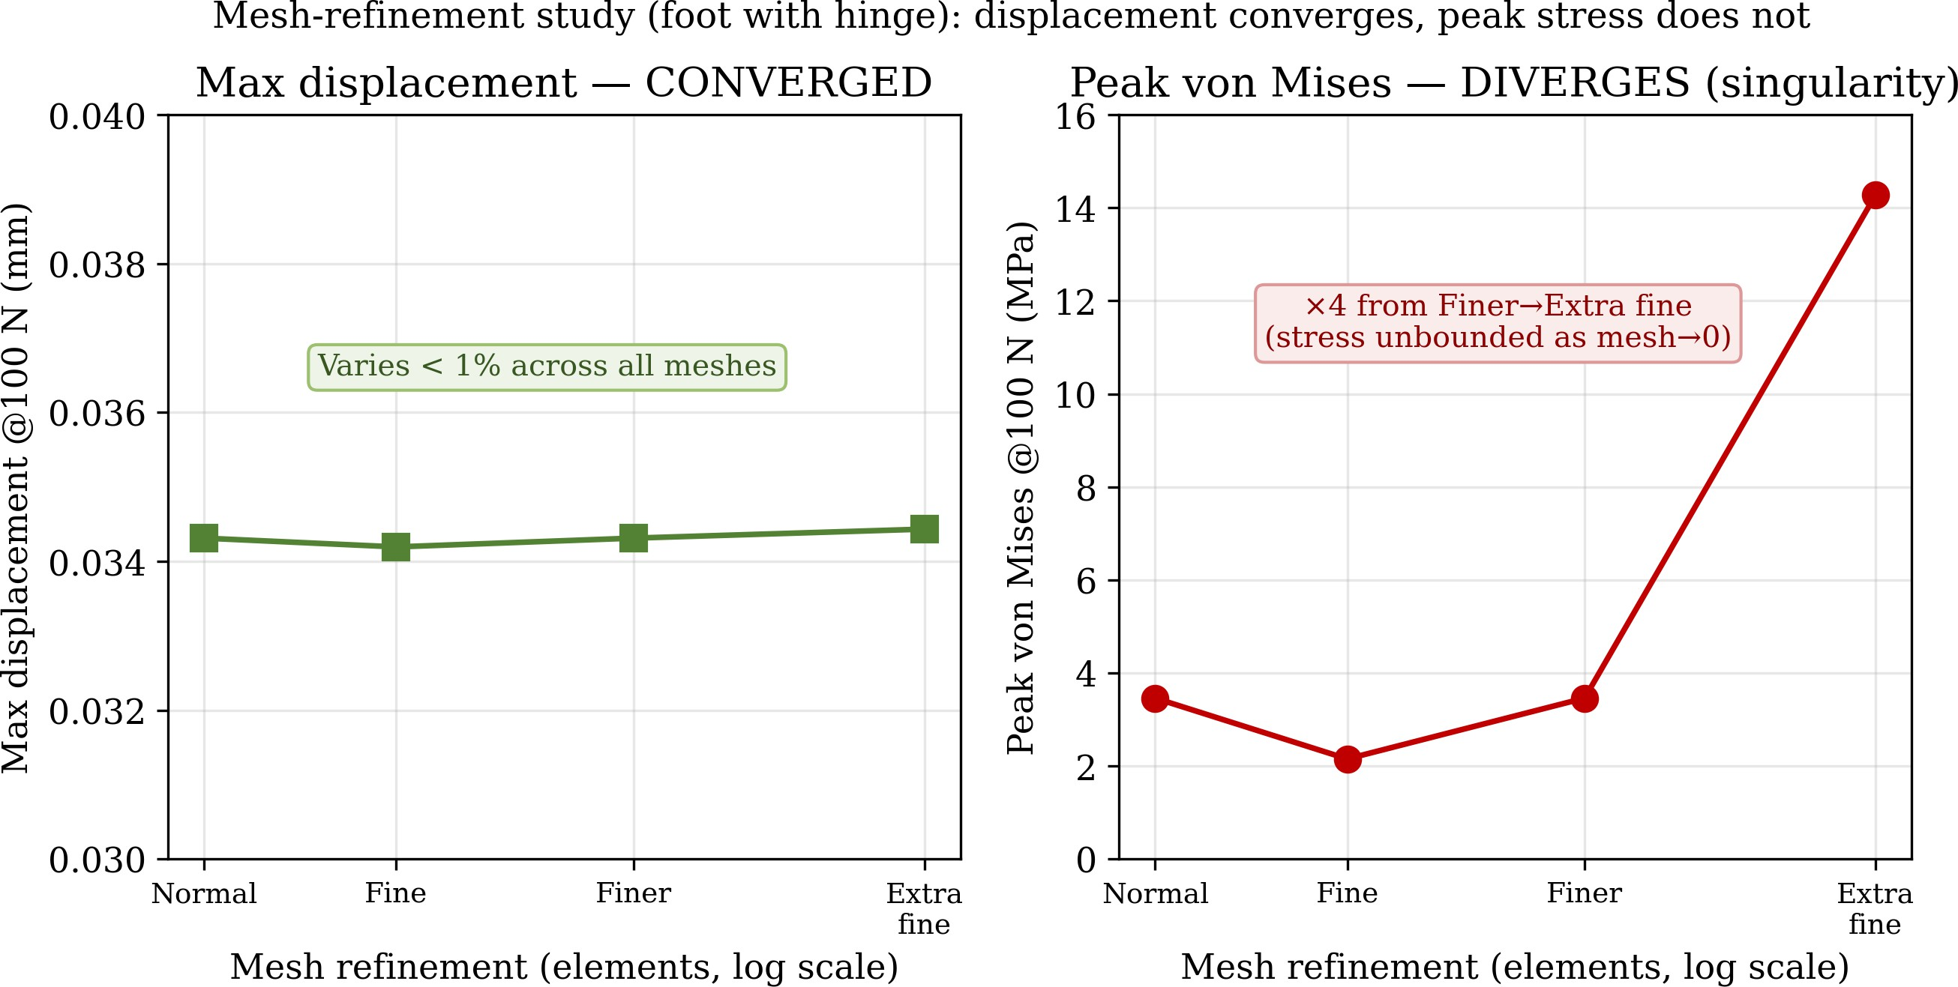

Figure 8.1. Mesh-refinement study. The maximum displacement (left) is fully converged, whereas the peak von Mises stress (right) diverges with refinement, identifying it as a stress singularity at a sharp corner rather than a physical stress.

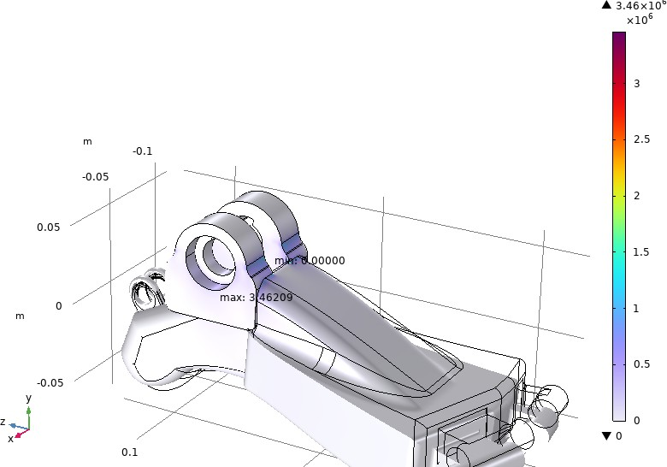
Figure 8.2. Location of the peak von Mises stress (the ‘max’ marker) at the sharp re-entrant corner where the inclined load-transfer rib meets the body near the hinge. Because the linear-elastic stress is unbounded at this corner, the peak value is mesh-dependent (Figure 8.1) and is treated as a singularity rather than a physical stress.

Loads and boundary conditions
All loads were declared as global parameters so that they could be swept; they are summarised in Table 8.6 and their application is illustrated in Figure 8.3.
Table 8.6. Global parameters, loads and thermal boundary values.

Parameter | Symbol | Value | Meaning
Vertical stance load | Fstance | 100 N (baseline) | Body load transferred through the ankle
Maximum lead-screw force | Factuator | 900 N | Peak actuator force capability
Motor and electronics mass | mremote | 0.25 kg | Remote mass carried by the assembly
Ambient air temperature | Tamb | 293.15 K (20 °C) | Surrounding air
Natural convection coefficient | hair | 15 W/(m²·K) | Heat loss to still air
Ground/sole convection | hground | 50 W/(m²·K) | Heat loss through the sole to ground
Hinge/bearing heat flux | qhinge | 30 W/m2 | Frictional heat at the ankle hinge
Crank/lead-screw heat flux | qcrank | 50 W/m² (baseline) | Heat from the crank/lead-screw contact

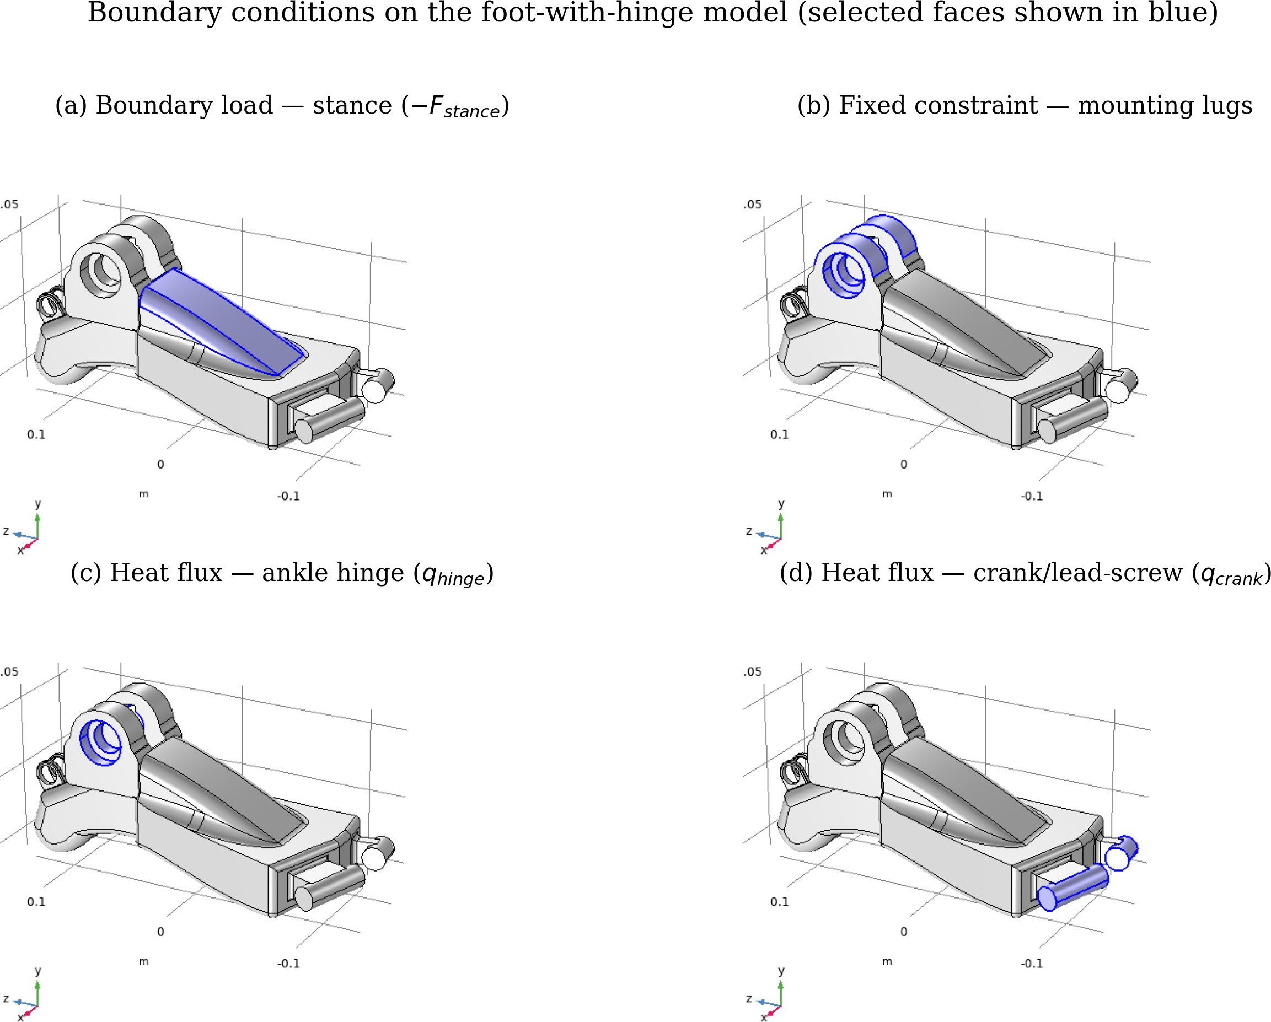
Figure 8.3. Boundary conditions applied to the foot-with-hinge model (selected faces shown in blue). (a) Vertical stance load −Fstance on the dorsal load-transfer surface; (b) fixed constraint at the ankle-hinge mounting lugs; (c) prescribed inward heat flux qhinge at the hinge bearing; (d) prescribed inward heat flux qcrank at the lead-screw/crank pins. All other exposed surfaces carry external air convection at Tamb.
For the structural problem the mounting lugs were given a fixed constraint (zero displacement), the stance load was applied as a boundary load of total force −Fstance in the vertical direction on the load-transfer surface, and gravity acted on the whole model. The stance load was swept from 100 to 900 N. These represent partial-loading verification cases rather than full single-limb body weight; for context, single-leg stance for a 75-kg user is ≈ 735 N and the peak vertical ground-reaction force during gait reaches two to three times body weight [19]. The 900 N case is used as a conservative proxy for the peak axial actuator force reacted at the foot plate.

Actuator heat source: the TD-8120MG servo
The dominant heat source at the crank is the actuator itself. The powered ankle is driven by a TD-8120MG digital servo, whose manufacturer specifications are summarised in Table 8.7 [20]. It is a 56-g carbon-brush DC servo with an aluminium-alloy and engineering-plastic (PBT) case, operating at 4.8–7.2 V, with a stall torque of 20.5–22.8 kg·cm and a stall current of 2.1–2.7 A. In a brushed DC motor essentially all of the electrical input is converted to heat whenever the output shaft is not delivering mechanical work — that is, while the lead screw holds a static load or is back-driven, which covers much of the stance phase. The dissipated power therefore ranges from about 1.9 W at no load (7.2 V × 0.26 A) to about 19 W at stall (7.2 V × 2.7 A).
Table 8.7. TD-8120MG digital-servo specifications and estimated heat dissipation [20].

Specification | At 4.8 V | At 7.2 V
No-load current | 210 mA | 260 mA
Stall current | 2.1 A | 2.7 A
Stall torque | 20.5 kg·cm | 22.8 kg·cm
No-load speed | 0.18 s / 60° | 0.14 s / 60°
Heat dissipation (no-load → stall) | 1.0 → 10.1 W | 1.9 → 19.4 W
This electrical loss is the physical origin of the crank heat-flux boundary condition, and provides the required linkage between the actuator and the thermal model. Only a fraction of the servo loss is conducted into the printed PETG holder across the bolted and pinned mounting interface; the remainder is carried away by the servo's own metallic housing and lost to the surrounding air. The contact patch over which the flux is applied, measured by

surface integration on the geometry, is A
passive bearing). The baseline q
crank
= 36.3 cm2 (and A
2
hinge
= 37.2 cm2 for the

crank = 50 W/m therefore corresponds to a conducted
power of only 0.18 W, of the order of one per cent of the continuous servo loss; the sweep to 100 W/m2 (0.36 W) bounds the uncertainty in this conducted fraction, and the hinge flux (30 W/m2, 0.11 W) represents passive bearing friction. The consequence of this small admissible
power for the printed part is analysed in Section 8.5.6.

Study design
Three studies were solved on the foot with hinge: (1) a structural analysis using the Solid Mechanics interface, sweeping the stance load Fstance over 100, 300, 600 and 900 N; (2) a thermal analysis using the Heat Transfer in Solids interface, sweeping the crank heat flux

qcrank
over 25, 50, 75 and 100 W/m2; and (3) a second thermal analysis sweeping the
2

convection coefficient hair over 5, 10, 15 and 20 W/(m ·K). All stationary problems were
solved with COMSOL's default direct solver (MUMPS) and with geometric nonlinearity disabled, consistent with the small computed strains.

Structural results
The maximum displacement grows linearly with stance load, from 0.034 mm at 100 N to
0.325 mm at 900 N (Figure 8.5), and is fully mesh-converged, so the part is very stiff and its deformation negligible relative to its dimensions. The highest converged von Mises stress in the body of the part — evaluated with the singular corner excluded — rises linearly from 3.2 MPa at 100 N to 30.5 MPa at the 900 N actuator load, giving factors of safety against the 50 MPa PETG yield strength of 15.6 and 1.6 respectively (Table 8.8). The stress field is shown in Figure 8.4; the stress concentrates around the hinge lugs and the load-transfer rib, while the bulk of the body remains lightly loaded.
Table 8.8. Converged structural results versus stance load (corner singularity excluded).

Fstance (N) | Peak von Mises (MPa) | Factor of safety | Max displacement (mm)
100 | 3.20 | 15.6 | 0.034
300 | 10.04 | 5.0 | 0.107
600 | 20.28 | 2.5 | 0.216
900 | 30.53 | 1.6 | 0.325

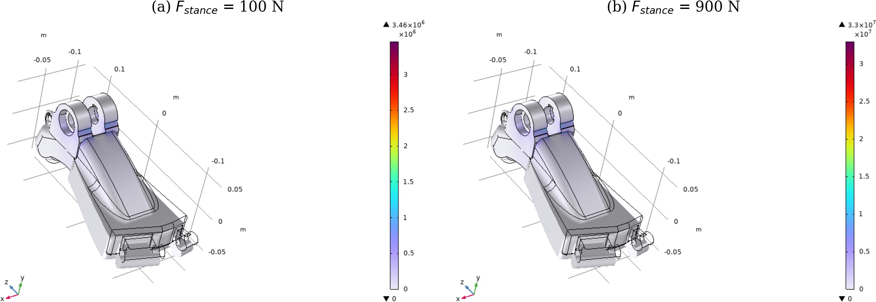

Figure 8.4. Von Mises stress field on the PETG foot with hinge at (a) the 100 N baseline stance load and
(b) the 900 N peak actuator load. The stress concentrates around the hinge lugs and the load-transfer rib; the bulk of the body remains lightly stressed.
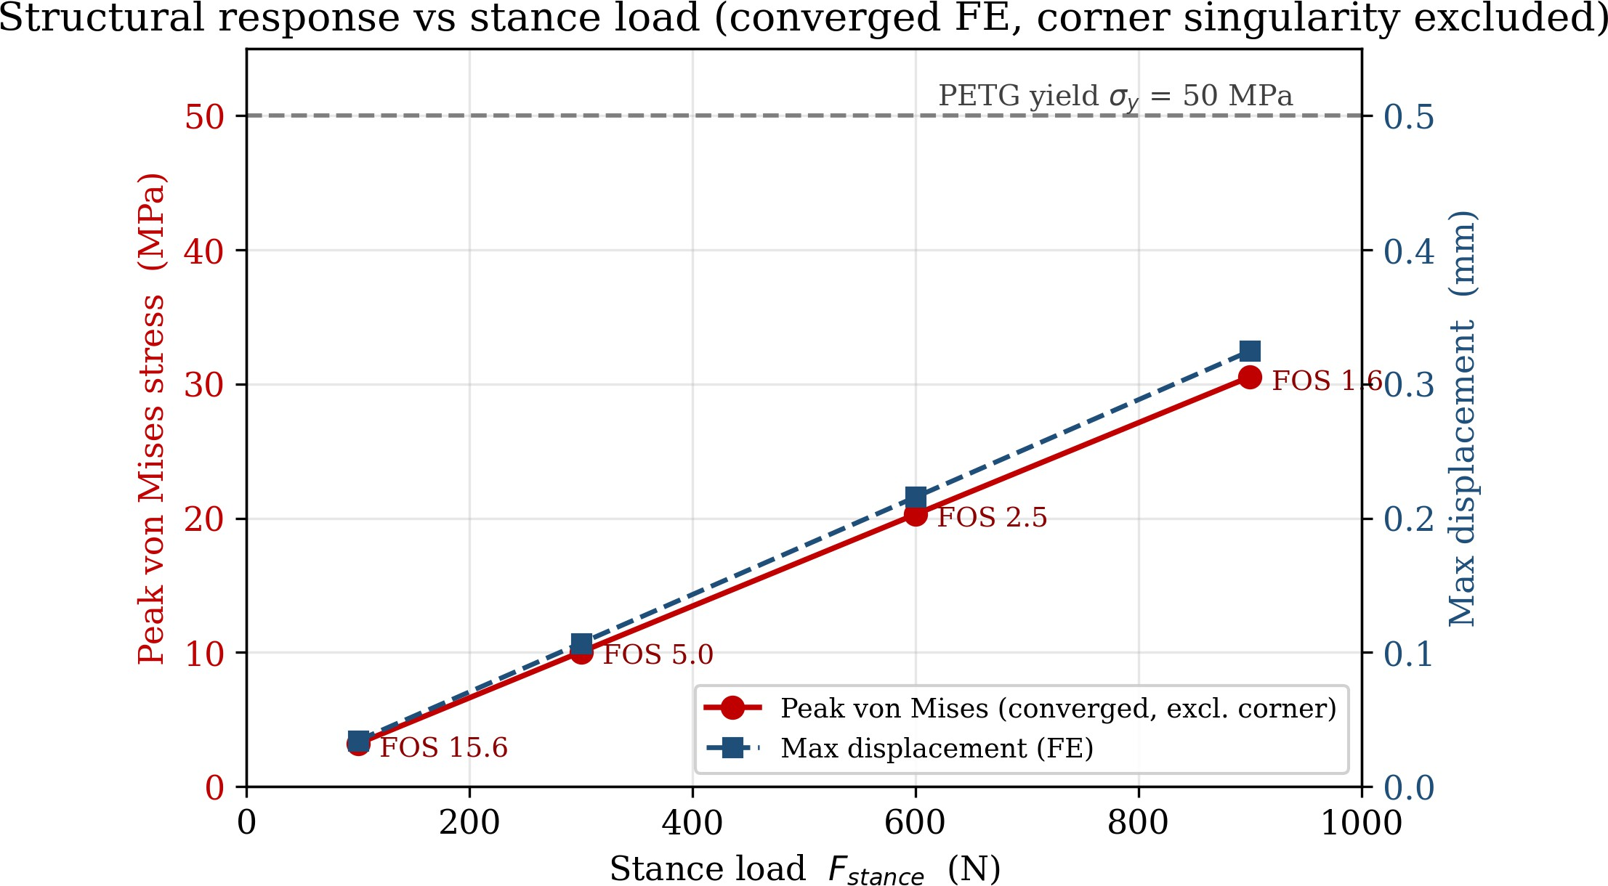

Figure 8.5. Converged peak von Mises stress (corner singularity excluded) and maximum displacement versus stance load. Both scale linearly with load; the factor of safety falls from 15.6 at nominal stance to
1.6 at the extreme 900 N actuator load.

The part therefore remains elastic across the whole range, with a large margin at nominal stance and a reduced but still adequate margin of about 1.6 at the extreme actuator load. Superimposed on this field, the linear-elastic model predicts an unbounded stress at the sharp rib-to-body corner (33 MPa on the Finer mesh, rising to 136 MPa on the Extra-fine mesh; Figures 8.1 and 8.2). This is a numerical singularity rather than a physical stress; it should be removed by adding a fillet (radius of a few millimetres) at that junction, which would also raise the local margin [18].

Effect of print anisotropy on the factor of safety
Because the simulations use bulk isotropic properties, the factors of safety in Table 8.8 are upper bounds for a printed part. Applying a conservative inter-layer knock-down factor of 0.50–0.75 to the 50 MPa bulk yield strength [16], [17] reduces the converged factor of safety at the 900 N actuator load to between about 0.8 and 1.2, so the extreme actuator case becomes marginal once print anisotropy is accounted for; at the 100 N nominal stance load the margin remains large (about 8–12) under the same knock-down. Two practical

measures follow: the part should be printed with its layer planes oriented transverse to the principal tensile direction at the rib root, and the rib-root fillet recommended above should be adopted to remove the local stress raiser. With these measures the printed component retains a positive margin throughout its intended operating envelope, while the nominal stance condition — the loading the device experiences for the great majority of its service life — remains comfortably safe.

Thermal results

With the baseline thermal loads (qcrank
= 50 W/m2, h

air
= 15 W/(m2·K)) the steady-state field

is summarised in Table 8.9. The hot region is localised at the crank and lead-screw-holder end of the part (Figure 8.6); the remainder of the body stays within a fraction of a degree of ambient, because the thin PETG section and the convective surfaces shed the modest applied heat efficiently.
Table 8.9. Thermal results at the baseline operating condition.

Quantity | Value
Maximum temperature, Tmax | 319.4 K (≈ 46.3 °C)
Minimum temperature, Tmin | 293.15 K (20.0 °C, ambient)
Volume-average temperature, Tmean | 293.65 K (≈ 20.5 °C)
Maximum thermal gradient | 2.87 × 10⁴ K/m
Mean total heat-flux magnitude | 6.83 W/m²
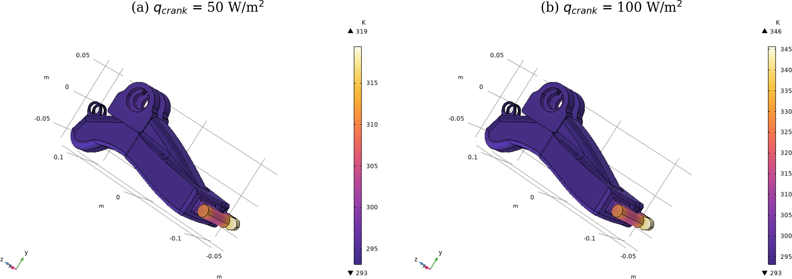

Figure 8.6. Surface temperature field on the foot with hinge at (a) the baseline crank heat flux of 50 W/m² (peak ≈ 46 °C) and (b) an elevated flux of 100 W/m² (peak ≈ 73 °C). The hot region is confined to the crank/lead-screw-holder end; the foot body stays near ambient.
The effect of the crank heat flux is summarised in Table 8.10 and Figure 8.7: the peak temperature rises linearly with the imposed flux, by 13.1 K for every 25 W/m2. The effect of the convection coefficient is given in Table 8.11 and Figure 8.8; increasing the air convection lowers the peak temperature only weakly (0.22 K over a four-fold increase in hair), which shows that the local hot region is limited by conduction through the insulating PETG rather than by surface convection. Radiation was neglected, which is justified at these temperatures.
Table 8.10. Effect of the crank heat flux on the temperature field.

2  qcrank (W/m ) | Tmax (K) | Tmax (°C) | Tmean (K) | Mean flux (W/m²)
25 | 306.29 | 33.1 | 293.45 | 4.22
50 | 319.43 | 46.3 | 293.65 | 6.83
75 | 332.57 | 59.4 | 293.86 | 9.43
100 | 345.71 | 72.6 | 294.07 | 12.03
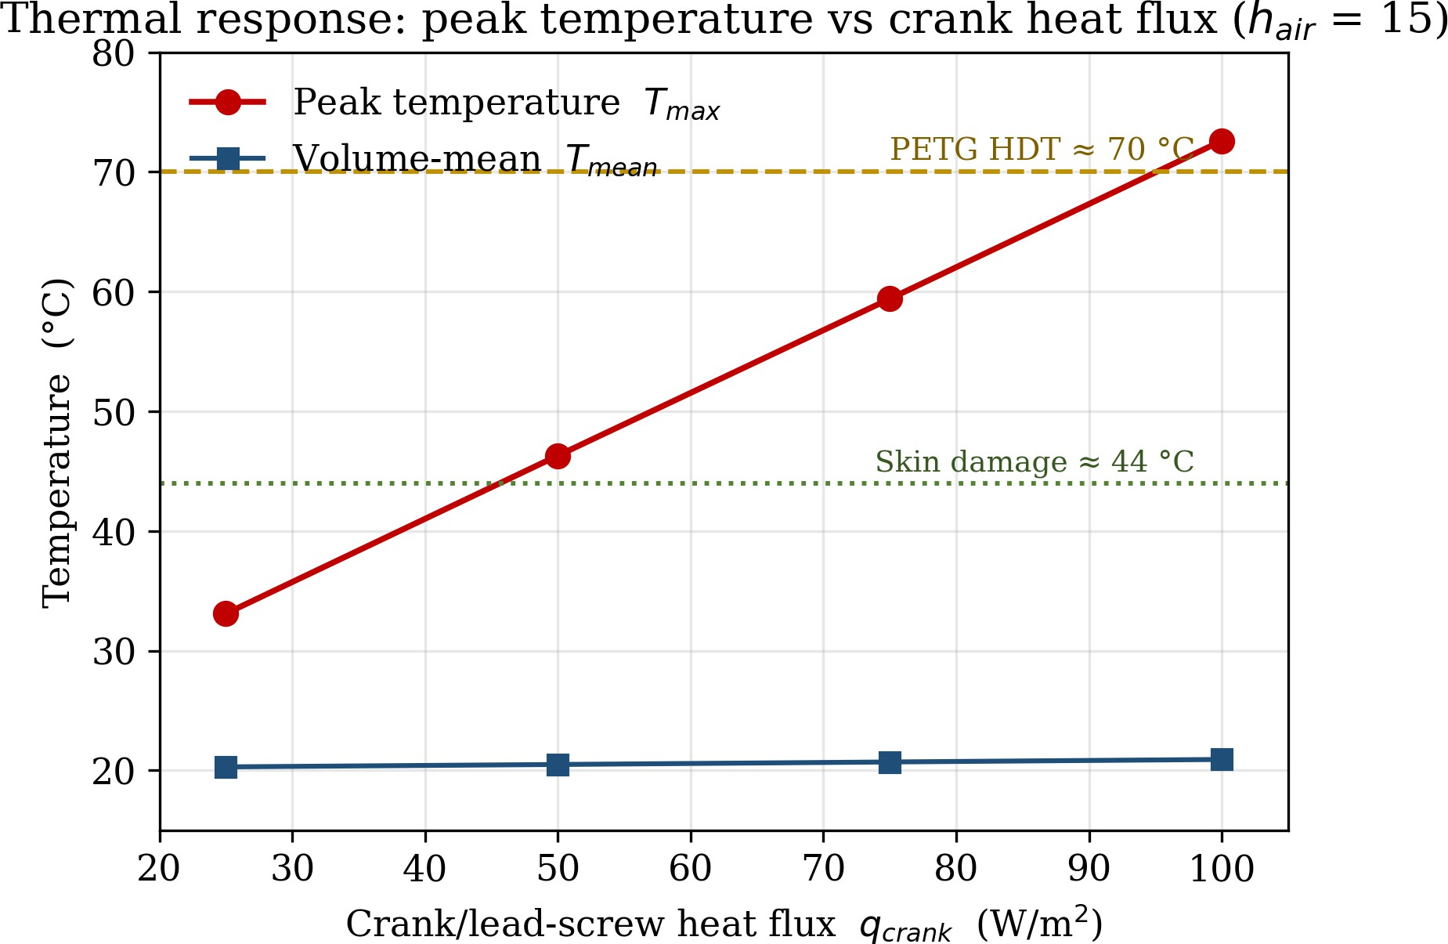
Figure 8.7. Peak and volume-mean temperature versus crank heat flux. The peak temperature is linear in the flux and reaches the PETG heat-deflection range (≈ 70 °C) near 100 W/m².

Table 8.11. Effect of the convection coefficient on the temperature field.

2  hair (W/(m ·K)) | Tmax (K) | Tmean (K) | Mean flux (W/m²)
5 | 319.61 | 293.84 | 7.80
10 | 319.49 | 293.70 | 7.12
15 | 319.43 | 293.65 | 6.83
20 | 319.39 | 293.63 | 6.66

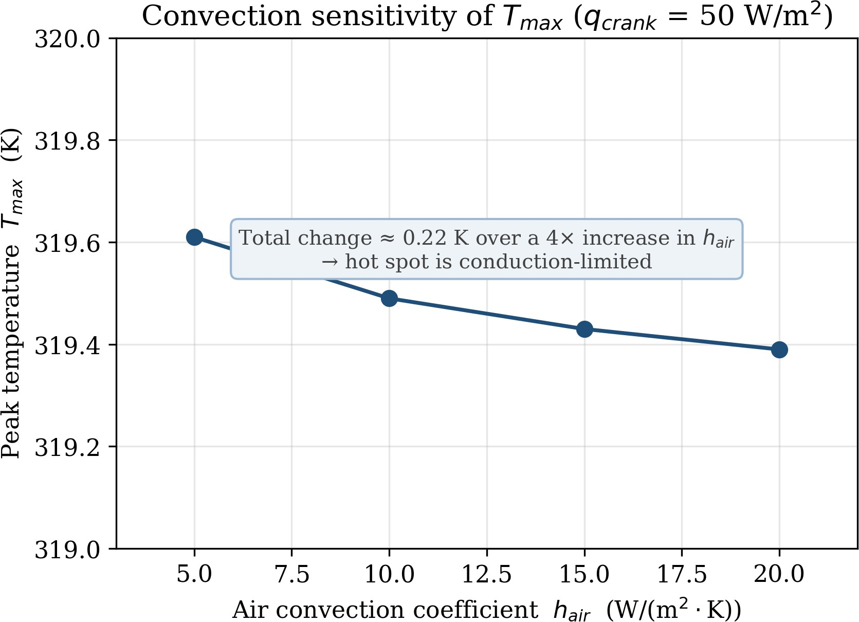

Figure 8.8. Peak temperature versus air convection coefficient. The very weak dependence confirms that the hot spot is conduction-limited.

It is informative to compare these temperatures with the polymer's own limits rather than only with tissue thresholds. The baseline 46 °C hot spot is well below the heat-deflection temperature of PETG (≈ 70 °C) and its glass transition (≈ 80 °C) [14]. At the elevated flux of
100 W/m2, however, the 72.6 °C peak reaches the heat-deflection range, identifying the
crank/lead-screw interface as the limiting location for both polymer softening and thermal management.

Discussion: implications for tissue and design safety
The structural study shows that the PETG foot carries the stance load elastically, with a converged factor of safety of about 16 at the nominal stance load and about 1.6 at the extreme 900 N actuator load, and with negligible deflection (0.325 mm). The load path to the socket, and therefore the pressure delivered to the residual limb, is consequently stable and predictable. The thermal study shows that, at the expected operating flux of about 50 W/m2, the maximum surface temperature stays around 46 °C and is confined to the actuator end, away from the skin-contact region, while the body of the part remains essentially at ambient temperature.
The part is, however, highly sensitive to the conducted heat. Because PETG is a thermal insulator and the contact patch is small, the model gives a near-linear response of about 145
°C per watt entering the crank holder, so the PETG heat-deflection temperature (≈ 70 °C) is
2
reached at only about 0.35 W; the qcrank = 100 W/m case (0.36 W) already returns 72.6 °C.
As the TD-8120MG servo can dissipate 1.9–19 W (Section 8.5.2.1), the crank/lead-screw holder can absorb only a small fraction of a watt before softening, and the baseline 46 °C result is valid only if the servo is thermally decoupled from the printed structure by its housing and an air gap. The crank/lead-screw interface is therefore the thermally critical location of the design: a deliberate thermal break — a metal heat-spreader or standoff that routes motor heat away from the PETG — is recommended, and in its absence the

conducted power should be verified experimentally to remain below about 0.3 W. With these provisions, PETG is an adequate and safe choice for the printed ankle component.

Simulation of the Supporting Components
The ankle foot with hinge does not act in isolation. Four further load-bearing components of the prosthesis were modelled and screened using the same workflow, so that the structural and, where relevant, the thermal integrity of the complete assembly could be established. Each component is described below, and the results are collected in Table 8.12.

Powered ankle hinge: PETG versus PLA
The powered hinge was modelled with the Solid Mechanics interface as a single linear-elastic domain, subject to a fixed constraint at its mounting face, a boundary load representing the actuation force, and gravity. The model was solved twice, once with PETG and once with PLA assigned to the domain, to compare the two candidate print materials under identical loading. This direct comparison, together with the property data of Section 8.4.3, supported the decision to adopt PETG for the printed parts and provided the simplified hinge baseline later extended into the full ankle foot-with-hinge model of Section 8.5.

Lead-screw holder: coupled structural and thermal analysis
The lead-screw holder carries the actuator and is exposed both to the actuation force and to the heat generated at the lead-screw contact. It was therefore modelled with two coupled physics interfaces, Solid Mechanics and Heat Transfer in Solids, and solved in a stationary structural study and a thermal study. The thermal boundary conditions comprised an inward heat flux at the lead-screw contact and external air convection on the exposed surfaces. The holder was analysed in a high-strength alloy-steel version and in a PETG version, which demonstrated the combined methodology on a single part and allowed the metal and polymer options to be compared on a consistent basis.

Motor joint shaft
The motor joint shaft transmits the actuator torque and was modelled in steel (AISI 4340) using the Solid Mechanics interface. Three boundary loads represented the actuator force and the associated reactions at the joint. The analysis returned a peak von Mises stress of about 9.63 MPa, far below the yield strength of the alloy steel (≈ 470 MPa annealed, and substantially higher when heat-treated [21]), so the shaft operates with a factor of safety in excess of 40.

Electronics enclosure
The electronics enclosure protects the control hardware and the BCI electronics. It was modelled in PETG with the Solid Mechanics interface under a representative boundary load. The analysis returned a peak von Mises stress of about 1.01 MPa, a peak first-principal stress of about 1.27 MPa and a maximum displacement of about 0.023 mm, corresponding to a factor of safety of about 49.6. The enclosure is therefore very conservatively dimensioned, as is appropriate for a protective housing.
Table 8.12. Summary of the structural and thermal results for the simulated components.

Component | Material | Physics | Peak von Mises | Factor of safety
Foot with hinge (100 N) | PETG | Structural + thermal | 3.20 MPa | 15.6
Foot with hinge (900 N) | PETG | Structural + thermal | 30.5 MPa | 1.6
Powered hinge ‡ | PETG / PLA | Structural | both materials elastic | both > 1
Lead-screw holder ‡ | Steel / PETG | Coupled struct.+thermal | both options safe | both > 1
Motor joint shaft | AISI 4340 | Structural | 9.63 MPa | > 40
Electronics enclosure | PETG | Structural | 1.01 MPa | 49.6
‡ The powered hinge and the lead-screw holder were comparative studies — PETG versus PLA, and steel versus PETG, respectively — whose purpose was material selection rather than the verification of a single peak stress; in every case both candidate materials remained elastic under the applied actuation load. Across all of the components the computed stresses remain well within the strength of the chosen materials, and the temperatures remain within a safe range, so the campaign provides a consistent, quantitative screening of the mechanical and thermal integrity of the prosthesis as a whole.

Thermal Feature Extraction for Data-Driven Analysis
Beyond the verification of a single design, the project also built an automated pipeline that converts the COMSOL thermal simulations into a structured dataset, so that the relationship between design parameters and thermal performance can eventually be learned and predicted rather than re-simulated each time. For each solved model the temperature field, together with its spatial coordinates, and the heat-flux components and their magnitude were exported as spreadsheet data, with one row per mesh node. A small accompanying table recorded the scalar metadata for every model, namely the material name, the heat-source power and the ambient temperature.
On the analysis side, a Python pipeline based on the pandas, NumPy and SciPy libraries computed about forty descriptive features for each simulation. These were grouped into temperature statistics (minimum, maximum, mean, standard deviation, range and distribution shape); hot-region descriptors (the peak value, its location and the fraction of the domain above a chosen threshold); thermal-gradient measures; heat-flux measures; and thermal-resistance indicators, including the thermal resistance Rth = ΔT / Q and its inverse. The feature rows for all simulations were concatenated into a single consolidated dataset, which was then validated and visualised.
In its present form the pipeline is demonstrated on the foot-with-hinge thermal sweeps (twelve solved cases for a single geometry) and standardises feature extraction and dataset assembly. Predictive surrogate modelling and geometry-driven prediction are identified as future work: they will require a campaign that varies the geometry (for example wall thickness and fillet radius) and material across many simulations to supply the training diversity that a single geometry cannot provide.

Limitations and Conclusions
The analyses are subject to four main limitations. (i) Material model: isotropic bulk properties were used, whereas FDM PETG is anisotropic with reduced inter-layer strength

and partial infill, so the reported factors of safety are optimistic [16], [17]. (ii) Loading: only static stance and actuator cases were solved; gait is cyclic (of order 106 cycles per year), and fatigue — the dominant failure mode for printed polymers — was not assessed. (iii) Boundary conditions: heat inputs were prescribed as estimated surface fluxes rather than measured motor power, and the peak stress occurs at a geometric singularity that is mesh-sensitive [18]. (iv) Validation: the results were not yet checked against experiment. A direct validation is proposed as immediate future work: the predicted tip deflection (0.325 mm at 900 N) would be compared against a dial-gauge or digital-image-correlation measurement under a calibrated load, and the predicted rib-root and crank-holder temperatures against thermocouple readings during powered operation. Each of these is a candidate for future work.
This chapter applied COMSOL Multiphysics to verify the mechanical and thermal behaviour of a BCI-controlled powered prosthesis. The finite-element solvers for solid mechanics and heat transfer predicted the stress, displacement and temperature fields that ultimately govern the safety of the device for the human tissue that it contacts. Candidate biomaterials were classified into metals, ceramics, polymers and composites, and PETG was selected and characterised for the printed parts on the basis of its toughness, its thermal behaviour and its compatibility with skin, in preference to PLA. The ankle foot with hinge, the central manufactured component, was analysed in full: under loads ranging from 100 N nominal stance to 900 N peak actuator force it remained elastic, with a converged minimum factor of safety of about 1.6 and a maximum deflection of 0.325 mm, and under realistic actuator heating its surface temperature stayed near 46 °C, confined to the actuator end and away from the skin-contact region. The analysis also identified two design-critical features — a stress singularity at the rib-to-body corner, to be removed by a fillet, and the thermally sensitive crank/lead-screw interface, to be protected by a thermal break. The supporting components were each modelled and screened and found to operate within the strength of their materials and within a safe temperature range. Together these results demonstrate that the prosthesis, and in particular its printed PETG ankle component, is both structurally and thermally safe within its intended operating envelope, provided the two design recommendations are implemented.

References
- COMSOL AB, COMSOL Multiphysics Reference Manual, Version 6.1. Stockholm, Sweden: COMSOL AB, 2022.
- R. G. Budynas and J. K. Nisbett, Shigley's Mechanical Engineering Design, 10th ed. New York: McGraw-Hill Education, 2015.
- F. P. Incropera, D. P. DeWitt, T. L. Bergman, and A. S. Lavine, Fundamentals of Heat and Mass Transfer, 6th ed. Hoboken, NJ: John Wiley and Sons, 2007.
- A. F. T. Mak, M. Zhang, and D. A. Boone, “State-of-the-art research in lower-limb prosthetic biomechanics–socket interface: A review,” Journal of Rehabilitation Research and Development, vol. 38, no. 2, pp. 161–174, 2001.
- D. M. Sengeh and H. Herr, “A variable-impedance prosthetic socket for a transtibial amputee designed from magnetic resonance imaging data,” Journal of Prosthetics and Orthotics, vol. 25, no. 3, pp. 129–137, 2013.
- A. R. Moritz and F. C. Henriques, “Studies of thermal injury II: The relative importance of time and surface temperature in the causation of cutaneous burns,” American Journal of Pathology, vol. 23, no. 5, pp. 695–720, 1947.

- ISO 13732-1:2006, Ergonomics of the Thermal Environment — Methods for the Assessment of Human Responses to Contact with Surfaces — Part 1: Hot Surfaces. Geneva: International Organization for Standardization, 2006.
- D. F. Williams, “On the mechanisms of biocompatibility,” Biomaterials, vol. 29, no. 20, pp. 2941–2953, 2008.
- ISO 10993-1:2018, Biological Evaluation of Medical Devices — Part 1: Evaluation and Testing Within a Risk Management Process. Geneva: International Organization for Standardization, 2018.
- B. D. Ratner, A. S. Hoffman, F. J. Schoen, and J. E. Lemons, Biomaterials Science: An Introduction to Materials in Medicine, 3rd ed. Oxford: Academic Press, 2013.
- M. Geetha, A. K. Singh, R. Asokamani, and A. K. Gogia, “Ti based biomaterials, the ultimate choice for orthopaedic implants — A review,” Progress in Materials Science, vol. 54, no. 3, pp. 397–425, 2009.
- J. Barrios-Muriel, F. Romero-Sánchez, F. J. Alonso-Sánchez, and D. Rodríguez Salgado, “Advances in orthotic and prosthetic manufacturing: A technology review,” Materials, vol. 13, no. 2, art. 295, 2020.
- K. Durgashyam, M. Indra Reddy, A. Balakrishna, and K. Satyanarayana, “Experimental investigation on mechanical properties of PETG material processed by fused deposition modeling,” Materials Today: Proceedings, vol. 18, pp. 2052–2059, 2019.
- M.-H. Hsueh, C.-J. Lai, S.-H. Wang, Y.-S. Zeng, C.-H. Hsieh, C.-Y. Pan, and W.-C. Huang, “Effect of printing parameters on the thermal and mechanical properties of 3D-printed PLA and PETG, using fused deposition modeling,” Polymers, vol. 13, no. 11, art. 1758, 2021.
- S. Farah, D. G. Anderson, and R. Langer, “Physical and mechanical properties of PLA, and their functions in widespread applications — A comprehensive review,” Advanced Drug Delivery Reviews, vol. 107, pp. 367–392, 2016.
- S. H. Ahn, M. Montero, D. Odell, S. Roundy, and P. K. Wright, “Anisotropic material properties of fused deposition modeling ABS,” Rapid Prototyping Journal, vol. 8, no. 4, pp. 248–257, 2002.
- J. M. Chacón, M. A. Caminero, E. García-Plaza, and P. J. Núñez, “Additive manufacturing of PLA structures using fused deposition modelling: Effect of process parameters on mechanical properties and their optimal selection,” Materials and Design, vol. 124, pp. 143–157, 2017.
- R. D. Cook, D. S. Malkus, M. E. Plesha, and R. J. Witt, Concepts and Applications of Finite Element Analysis, 4th ed. New York: John Wiley and Sons, 2002.
- D. A. Winter, Biomechanics and Motor Control of Human Movement, 4th ed. Hoboken, NJ: John Wiley and Sons, 2009.
- TD-8120MG Digital Servo — Specifications, manufacturer datasheet (file: TD-8120MG_Digital_Servo.pdf).
- ASM International, ASM Handbook, Volume 1: Properties and Selection: Irons, Steels, and High-Performance Alloys. Materials Park, OH: ASM International, 1990.

